# ­­­­­­

# TUGAS 1

## Soal

1. Berdasarkan game yang telah dibuat, tambahkan code untuk mengatasi collision (tumbukan) antara tap/ click dari player terhadap zombie dan knight. Jika tap pada zombie, akan menambahkan score namun jika tap pada knight akan mengurangi life point.
2. Draw heart seperti yang ada pada gambar 8.2 sebagai indikator untuk life point. Jika life point berkurang satu, maka indikator heart akan berkurang satu. Indikator heart akan hilang semua jika life point menjadi nol. Muncul tulisan “GAME OVER” dan tombol restart yang jika ditekan akan mengulang game dari awal.
3. Draw tree di layer paling belakang, bergerak dari kanan ke kiri dengan velocity mengikuti level dari game.
4. Buat Tombol pause menghentikan game sementara.

## Source Code

|  |  |
| --- | --- |
| index.html | |
| 1  2  3  4  5  6  7  8  9  10  11  12  13  14  15  16  17  18 | <html>  <head>  <title>Run Boy Run</title>  <link href="/favicon.ico" type="image/x-icon" rel="icon" />  <link rel="stylesheet" type="text/css" href="css/gamestyle.css" />  </head>  <body>  <div id="gameScreen">  <canvas id="cnv"></canvas>  </div>  <script src="js/gamescript.js"></script>  </body>  </html> |

|  |  |
| --- | --- |
| gamestyle.css | |
| 1  2  3  4  5  6  7  8  9  10  11  12  13  14  15  16  17 | #gameScreen {  position: relative;  background-image: url("../images/bg2.png");  background-size: 100%;  height: 360px;  width: 640px;  margin: 0 auto;  }  #cnv {  width: 100%;  }  #controller {  width: 100%;  padding: 10px;  } |

|  |  |
| --- | --- |
| gamescript.js | |
| 1  2  3  4  5  6  7  8  9  10  11  12  13  14  15  16  17  18  19  20  21  22  23  24  25  26  27  28  29  30  31  32  33  34  35  36  37  38  39  40  41  42  43  44  45  46  47  48  49  50  51  52  53  54  55  56  57  58  59  60  61  62  63  64  65  66  67  68  69  70  71  72  73  74  75  76  77  78  79  80  81  82  83  84  85  86  87  88  89  90  91  92  93  94  95  96  97  98  99  100  101  102  103  104  105  106  107  108  109  110  111  112  113  114  115  116  117  118  119  120  121  122  123  124  125  126  127  128  129  130  131  132  133  134  135  136  137  138  139  140  141  142  143  144  145  146  147  148  149  150  151  152  153  154  155  156  157  158  159  160  161  162  163  164  165  166  167  168  169  170  171  172  173  174  175  176  177  178  179  180  181  182  183  184  185  186  187  188  189  190  191  192  193  194  195  196  197  198  199  200  121  122  123  124  125  126  127  128  129  130  131  132  133  134  135  136  137  138  139  140  141  142  143  144  145  146  147  148  149  150  151  152  153  154  155  156  157  158  159  160  161  162  163  164  165  166  167  168  169  170  171  172  173  174  175  176  177  178  179  180  181  182  183  184  185  186  187  188  189  190  191  192  193  194  195  196  197  198  199  200  201  202  203  204  205  206  207  208  209  210  211  212  213  214  215  216  217  218  219  220  221  222  223  224  225  226  227  228  229  230  231  232  233  234  235  236  237  238  239  240  241  242  243  244  245  246  247  248  249  250  251  252  253  254  255  256  257  258  259  260  261  262  262  263  264  265  267  268  269  270  271  272  273  274  275  276  277  278  279  280  281  282  283  284  285  286  287  288  289  290  291  292  293  294  295  296  297  298  299  300  301  302  303  304  305  306  307  308  309  310  311  312  313  314  315  316  317  318  319  320  321  322  323  324  325  326  327  328  329  330  331  332  333  334  335  336  337  338  339  340  341  342  343  344  345  346  347  348  349  350  351  352  353  354  355  356  357  358  359  360  361  362  363  364  365  366  367  368  369  370  371  372  373  374  375  376  377  378  379  380 | (function() {  var knight,  knightImage,  level = 1,  velocity = 1,  numBush = 5,  numZombie = 3,  bush = [],  bushImage,  heart = [],  heartImage,  zombie = [],  score = 0,  life = 3,  gameOver = "",  btnRestart,  btnRestartImage,  animation = "",  isShowBtnRestart = false,  isBtnPauseClicked = false,  canvas,  btnPause,  btnPauseImage;  function gameLoop() {  animation = requestAnimationFrame(gameLoop);  canvas.getContext("2d").clearRect(0, 0, canvas.width, canvas.height);  var i;  btnPause.update();  btnPause.render();  knight.update();  knight.x -= level * velocity;  if (knight.x < -128) {  knight.x = canvas.width + Math.round(Math.random() * canvas.width);  }  knight.render();  for (i = 0; i < life; i++) {  heart[i].update();  heart[i].render();  }  for (i = 0; i < zombie.length; i++) {  zombie[i].update();  zombie[i].x -= level * velocity;  zombie[i].render();  if (zombie[i].x < -128) {  destroyZombie(zombie[i]);  setTimeout(spawnZombie, 1000);  life--;  }  if (score > level * 5) {  level++;  }  }  for (i = 0; i < bush.length; i++) {  bush[i].update();  bush[i].x += velocity / 2;  bush[i].render();  if (bush[i].x > canvas.width + 65) {  bush[i].x = -80 - Math.floor(Math.random() * 3 + 1);  }  }  if (life < 1) {  life = 0;  knight.w = 2640;  gameOver = "Game Over";  isShowBtnRestart = true;  btnRestart.update();  btnRestart.render();  setTimeout(stopAnimation, 600);  }  drawHud();  }  function sprite(options) {  var that = {},  frameIndex = 0,  tickCount = 0,  tickPerFrame = options.tickPerFrame || 0,  numberOfFrame = options.numberOfFrame || 1;  that.context = options.context;  that.w = options.w;  that.h = options.h;  that.img = options.img;  that.x = options.x;  that.y = options.y;  that.scaleRatio = 1;  that.update = function() {  tickCount += 1;  if (tickCount > tickPerFrame) {  tickCount = 0;  if (frameIndex < numberOfFrame - 1) {  frameIndex += 1;  } else {  frameIndex = 0;  }  }  };  that.render = function() {  that.context.drawImage(  that.img,  frameIndex * that.w / numberOfFrame,  0,  that.w / numberOfFrame,  that.h,  that.x,  that.y,  that.w / numberOfFrame,  that.h  );  };  that.getFrameWidth = function() {  return that.w / numberOfFrame;  }  return that;  }  function stopAnimation() {  cancelAnimationFrame(animation);  }  function drawHud() {  var context = canvas.getContext("2d");  context.font = "bold 20px Consolas";  context.textAlign = "start";  context.fillStyle = "white";  context.fillText("Score: " + score, canvas.width - 275, 50);  context.font = "bold 20px Consolas";  context.textAlign = "start";  context.fillStyle = "white";  context.fillText("Level: " + level, canvas.width - 125, 50);  context.font = "bold 20px Consolas";  context.textAlign = "start";  context.fillStyle = "white";  context.fillText("Life: ", 30, 50);  context.font = "bold 70px Consolas";  context.textAlign = "center";  context.fillStyle = "#193439";  context.fillText(gameOver, context.canvas.width / 2, context.canvas.height / 2 - 32);  }  canvas = document.getElementById("cnv");  canvas.width = 1024;  canvas.height = 460;  knightImage = new Image();  knight = sprite({  context: canvas.getContext("2d"),  w: 1740,  h: 210,  img: knightImage,  numberOfFrame: 10,  tickPerFrame: 5,  x: canvas.width,  y: canvas.height - 210  });  btnRestartImage = new Image();  btnRestart = sprite({  context: canvas.getContext("2d"),  w: 155,  h: 64,  img: btnRestartImage,  numberOfFrame: 1,  tickPerFrame: 1,  x: canvas.width / 2 - 70,  y: canvas.height / 2 - 10  });  btnPauseImage = new Image();  btnPause = sprite({  context: canvas.getContext("2d"),  w: 70,  h: 70,  img: btnPauseImage,  numberOfFrame: 0,  tickPerFrame: 0,  x: canvas.width / 2 - 30,  y: 15  });  function tap(e) {  var i,  loc = {},  dist,  distBtnRestart,  distBtnPause,  distKnight,  zombieToDestroy = [],  pos = getElementPosition(canvas),  tapX = e.targetTouches ? e.targetTouches[0].pageX : e.pageX,  tapY = e.targetTouches ? e.targetTouches[0].pageY : e.pageY,  canvasScaleRatio = canvas.width / canvas.offsetWidth;  loc.x = (tapX - pos.x) * canvasScaleRatio;  loc.y = (tapY - pos.y) * canvasScaleRatio;  for (i = 0; i < zombie.length; i++) {  dist = distance({  x: (zombie[i].x + zombie[i].getFrameWidth() / 2 * zombie[i].scaleRatio),  y: (zombie[i].y + zombie[i].getFrameWidth() / 2 * zombie[i].scaleRatio)  }, {  x: loc.x,  y: loc.y  });  if (dist < zombie[i].getFrameWidth() / 2 * zombie[i].scaleRatio) {  zombieToDestroy.push(zombie[i]);  console.log(zombie[i].x);  }  }  for (i = 0; i < zombieToDestroy.length; i++) {  destroyZombie(zombieToDestroy[i]);  setTimeout(spawnZombie, 1000);  }  if (zombieToDestroy.length) {  score++;  }  distBtnRestart = distance({  x: (btnRestart.x + btnRestart.getFrameWidth() / 2 * btnRestart.scaleRatio),  y: (btnRestart.y + btnRestart.getFrameWidth() / 2 * btnRestart.scaleRatio)  }, {  x: loc.x,  y: loc.y  });  distBtnPause = distance({  x: (btnPause.x + btnPause.getFrameWidth() / 2 * btnPause.scaleRatio),  y: (btnPause.y + btnPause.getFrameWidth() / 2 * btnPause.scaleRatio)  }, {  x: loc.x,  y: loc.y  });  if ((distBtnRestart < btnRestart.getFrameWidth() / 2 * btnRestart.scaleRatio) && isShowBtnRestart) {  document.location.reload();  }  console.log(isBtnPauseClicked);  if ((distBtnPause < btnPause.getFrameWidth() / 2 * btnPause.scaleRatio) && !isBtnPauseClicked) {  cancelAnimationFrame(animation);  isBtnPauseClicked = true;  var context = canvas.getContext("2d");  context.font = "bold 50px Consolas";  context.textAlign = "center";  context.fillStyle = "#193439";  context.fillText("Game Paused", context.canvas.width / 2, context.canvas.height / 2 - 32);  } else if ((distBtnPause < btnPause.getFrameWidth() / 2 * btnPause.scaleRatio) && isBtnPauseClicked) {  requestAnimationFrame(gameLoop);  isBtnPauseClicked = false;  }  distKnight = distance({  x: (knight.x + knight.getFrameWidth() / 2 * knight.scaleRatio),  y: (knight.y + knight.getFrameWidth() / 2 * knight.scaleRatio)  }, {  x: loc.x,  y: loc.y  });  if (distKnight < knight.getFrameWidth() / 2 * knight.scaleRatio) {  knight.x = canvas.width + Math.round(Math.random() * canvas.width);  life--;  }  }  function destroyZombie(param) {  var i;  for (i = 0; i < zombie.length; i++) {  if (zombie[i] === param) {  zombie[i] = null;  zombie.splice(i, 1);  break;  }  }  }  function spawnZombie() {  var zombieIndex,  zombieImage;  zombieImage = new Image();  zombieIndex = zombie.length;  zombie[zombieIndex] = sprite({  context: canvas.getContext("2d"),  w: 1740,  h: 210,  img: zombieImage,  numberOfFrame: 10,  tickPerFrame: Math.floor(Math.random() * 8) + 5  });  if ((zombieIndex % 2) == 1) {  zombieImage.src = "images/zombie_female_run.png";  } else {  zombieImage.src = "images/zombie_male_run.png";  }  zombie[zombieIndex].x = canvas.width + Math.random() * (canvas.width - zombie[zombieIndex].getFrameWidth() * zombie[zombieIndex].scaleRatio);  zombie[zombieIndex].y = canvas.height - 210;  zombie[zombieIndex].scaleRatio = Math.random() * 0.5 + 0.5;  }  function spawnBush() {  var bushIndex,  bushImage;  bushImage = new Image();  bushIndex = bush.length;  bush[bushIndex] = sprite({  context: canvas.getContext("2d"),  img: bushImage,  w: 0,  h: 0,  x: 0,  y: 0,  numberOfFrame: 1,  tickPerFrame: 1  });  bush[bushIndex].x = 0 + Math.random() * (canvas.width - bush[bushIndex].getFrameWidth() * bush[bushIndex].scaleRatio);  if (bushIndex == 0) {  bush[bushIndex].w = 173;  bush[bushIndex].h = 66;  bush[bushIndex].y = canvas.height - 62;  }  if (bushIndex == 1) {  bush[bushIndex].w = 93;  bush[bushIndex].h = 47;  bush[bushIndex].y = canvas.height - 45;  }  if (bushIndex == 2) {  bush[bushIndex].w = 54;  bush[bushIndex].h = 55;  bush[bushIndex].y = canvas.height - 53;  }  if (bushIndex == 3) {  bush[bushIndex].w = 53;  bush[bushIndex].h = 76;  bush[bushIndex].y = canvas.height - 74;  }  if (bushIndex == 4) {  bush[bushIndex].w = 330;  bush[bushIndex].h = 301;  bush[bushIndex].y = canvas.height - 275;  }  bush[bushIndex].scaleRatio = Math.random() * 0.5 + 0.5;  bushImage.src = "images/bush" + bushIndex + ".png";  }  function spawnHeart() {  var heartIndex,  heartImage;  heartImage = new Image();  heartIndex = heart.length;  heart[heartIndex] = sprite({  context: canvas.getContext("2d"),  w: 50,  h: 40,  img: heartImage,  numberOfFrame: 1,  tickPerFrame: 1  });  if (heartIndex == 0) {  heart[heartIndex].x = 100;  }  if (heartIndex == 1) {  heart[heartIndex].x = 140;  }  if (heartIndex == 2) {  heart[heartIndex].x = 180;  }  heart[heartIndex].y = 22;  heart[heartIndex].scaleRatio = Math.random() * 0.5 + 0.5;  heartImage.src = "images/life.png";  }  function getElementPosition(element) {  var parentOffset,  pos = {  x: element.offsetLeft,  y: element.offsetTop  }  if (element.offsetParent) {  parentOffset = getElementPosition(element.offsetParent);  pos.x += parentOffset.x;  pos.y += parentOffset.y;  }  return pos;  }  function distance(p1, p2) {  var dx = p1.x - p2.x,  dy = p1.y - p2.y;  return Math.sqrt(dx * dx + dy * dy);  }  for (i = 0; i < numZombie; i++) {  spawnZombie();  }  for (i = 0; i < numBush; i++) {  spawnBush();  }  for (i = 0; i < life; i++) {  spawnHeart();  }  gameLoop();  knightImage.src = "images/run-knight.png";  btnRestartImage.src = "images/restart.png";  btnPauseImage.src = "images/pause.png";  canvas.addEventListener("mousedown", tap);  canvas.addEventListener("touchstart", tap);  }()); |

## Screenshot

* 1. Tampilan game saat dijalankan

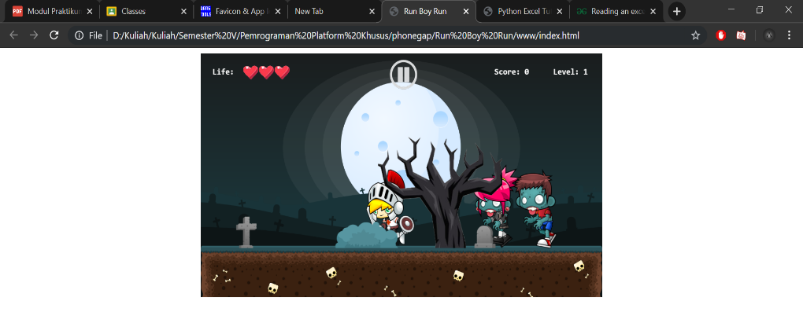

* 1. Tampilan game saat zombie diklik dan score bertambah

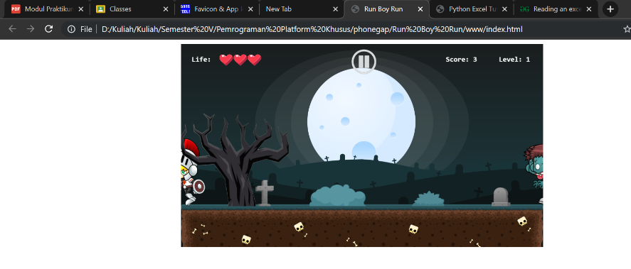

* 1. Tampilan saat level pada game meningkat

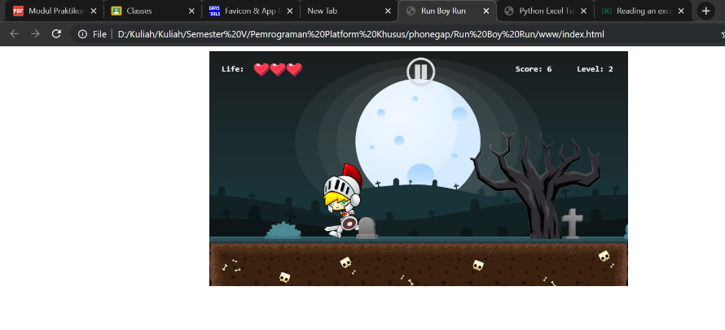

* 1. Tampilan saat nyawa berkurang

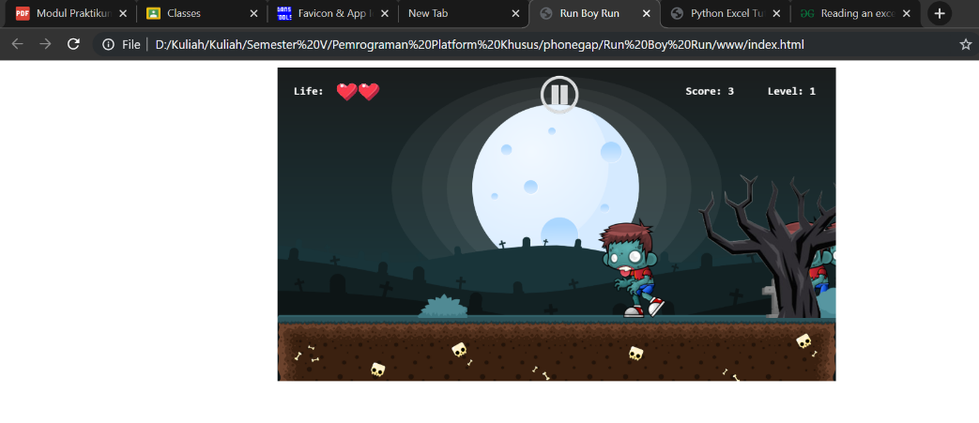

* 1. Tampilan saat game di pause

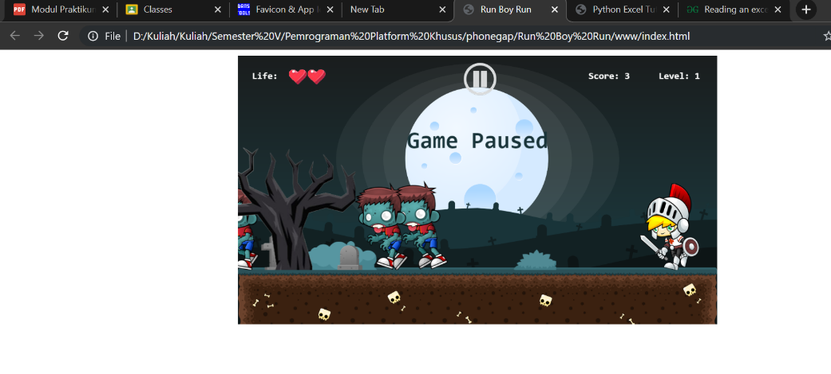

* 1. Tampilan saat game berakhir

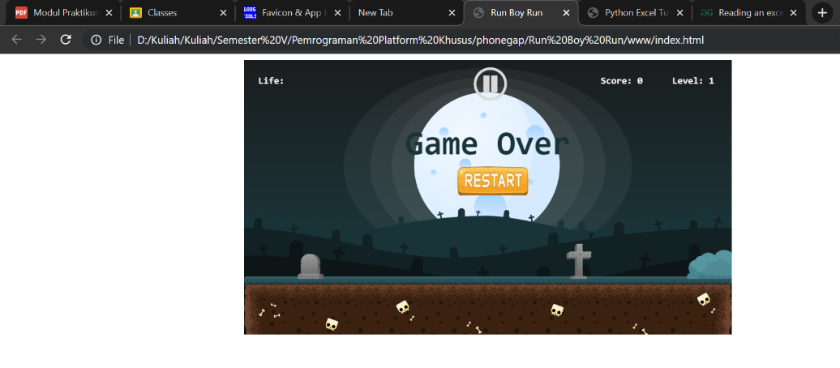

## Penjelasan

* 1. Untuk mengatasi collision antara knight dan zombie saat player melakukan klik atau tap, maka dilakukan modifikasi pada script dengan menambahkan seleksi if pada function gameloop. Jika knight yang diklik maka life akan berkurang dan sebaliknya jika zombie yang diklik maka score akan bertambah.
  2. Untuk menambahkan life berupa gambar hati hal yang dilakukan adalah dengan menambahkan variabel baru berupa heart dan heratImage. Setelah itu ditambahkan method spawnHeart untuk melakukan update pada jumlah hati yang dimiliki pemain. Selanjutnya adalah melakukan perubahan pada drawHud untuk menampilkan gambar hati tersebut.
  3. Disini dilakukan modifikasi pada jumlah variabel yang disimpan pada bushIndex untuk menambahkan asset berupa tree karena pada file images asset yang berupa tree/pohon tersebut bernama bush4.png. Setelah itu dilakukan penambahan seleksi if baru pada function spawnBush yang berisi ukuran dari asset pohon tersebut. Dengan begitu akan mencul asset baru berupa pohon yang bergerak dari kanan ke kiri sesuai dengan velocity pada game level.
  4. Untuk menambahkan tombol pause ditambahkan variabel baru berupa btnPause, btnPuseImage, dan isBtnPauseClicked. Setelah itu dilakukan perubahan pada function tap dengan menambahkan seleksi if baru ketika button pause tersebut diklik maka animasi pada game akan terhenti dan tulisan “Game Paused” akan muncul.